DSL MODEM TO COMPUTER

Welcome and thank you for choosing EvenLink, before starting, we suggest that you turn off your computer before connecting anything to it. We would also like to recommend that you read through the whole setup procedure before beginning, and remember, if you get stuck, or run into a problem, you can always call us at 570-988-1800 or 1-866-311-5900; now let us begin.
IMPORTANT!
DO NOT TAMPER WITH THE DO NOT REMOVE STICKER UNLESS INSTRUCTED BY AN EVENLINK SUPPORT TECHNICIAN. DOING SO MAY CAUSE YOUR INTERNET TO STOP WORKING.

Step #1 What is in the box: Inside of the box should be the following items: DSL Modem, Power adapter, DSL Filters, Telephone Cord, and a Network Cable (about twice the size of a phone cord & usually Red or Yellow).

Step #2 Installing DSL Filters: Before we can connect all of the hardware, we need to install DSL Filters on all the phones that share the same phone number as the DSL Line. Simply disconnect your phone cord from the wall and plug the filter into the wall and connect your phone cord into the filter. The only jack that you do not install a DSL Filter on is the phone jack for the DSL Modem
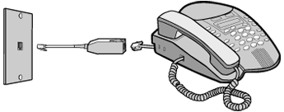
Step #3: Making the Connections: Now that we have all of our filters installed, we can move on and connect the DSL Modem
Step #3.1: First thing we are going to do is connect the Network Cable (the chord with the large plug) to the back of the computer and the other end to the back of the modem.
Step #3.2: Connect the phone line from the wall to the back of the modem (remember, do not install a filter here)
Step #3.3: Plug the power adapter into a power outlet and the other end into the modem,
Step #3.4: Press the power button on the back of the modem
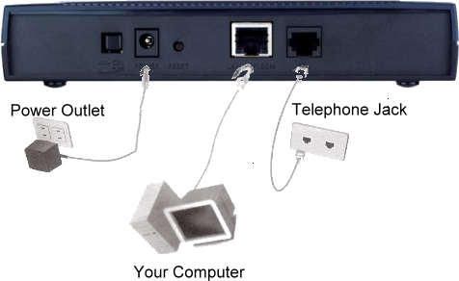

Step #4 Modem Status: Now with the DSL Modem connected and turned on, the lights on the front of the modem should be on, and will be lit up as follows:
PWR: Solid Green / SYS: Solid Green / 10M or 100M: Orange (It may blink or be off) / DSL: Green (It may blink)
If the lights are not the same as above, please check all of your connections to the modem, and if you cannot get it to light up like that, please call us, and we will gladly assist you.

Step #5 Finishing up the Modem Setup: We are done setting up the modem, you can now go ahead and turn on your computer and continue on to the next step, which is setting up your Computer so that is can use DSL.
Setting up Windows for DSL
Windows 95, 98 & ME
Step #1 (Win95/98/ME): Click on Start, Settings, Control Panel. Double click on Network. Find and double click on the TCP/IP listing for your NIC card. (It will look similar to figure 1.1)
Step #2 (Win95/98/ME): Select Obtain an IP address automatically on the IP Address tab and then click on the OK Button, it may ask for the Windows CD, after it finishes, please restart your computer. If you get a Windows Networking Box, Click OK . You should now be able to access the internet (figure 1.2)

Figure 1.1  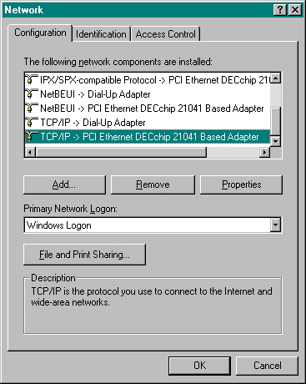 | Figure1.2  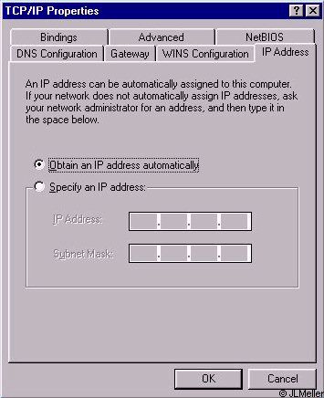

Windows 2000 & XP

Step #1 (Win2k/XP): (2K:) Click on Start, Settings, Network and Dial-Up Connections. (XP:) Click on Start, Control Panel, Network And Internet Connections, Network Connections. (Both:) Right click on Local Area Connection and select Properties. Click on Internet Protocol (TCP/IP) then the Properties button. (See figure 2.1)
Step #2 (Win2k/XP): Select Obtain an IP Address automatically. (See figure 2.2) Click the OK button then the Close or OK button.
Step #3: In your Control Panel is Internet Options – double click on that. Click on the Connections tab. Make sure there is a bullet next to Never Dial A Connection. Click Apply then OK, after completing these steps, please restart your computer, and you should now be able to access the internet.
If you require any help or have any questions feel free to call our office. We can be reached locally at 570-988-1800 or outside the local calling area at 1-866-311-5900. We can also be reached by email 24 hours a day at help@evenlink.com.
Figure 2.1 Figure 2.2
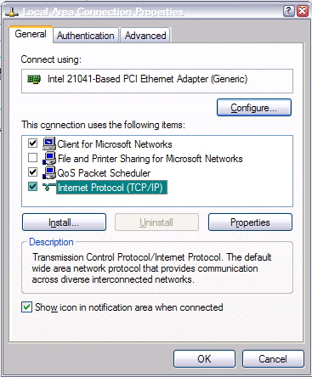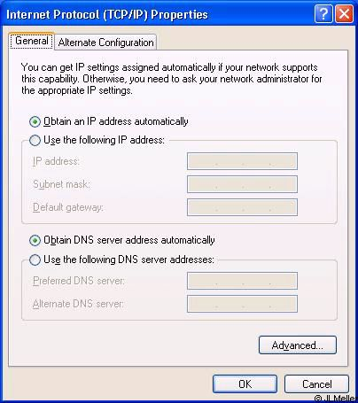

Set-Up Instructions for Additional Email Addresses with Identities in Outlook Express
Step #1: Open Outlook Express
Step #2: Click on “Tools”
Step #3: Then click on “Accounts”
Step #4: Click “ADD Mail”
Step #5: Next you will be asked to enter the Display Name. This is the name people will see when you send them an email. You can put anything you like in this box. You can put your proper name, nickname etc…. Once entered click on “NEXT”.
Step #6: Next you will be asked for the email address. This is where you will enter your additional email address. An example would be user@evenlink.com. User standing for your username for this email address. Once entered click on “NEXT”.
Step #7: At the top of the next box it should say “MY INCOMING MAIL SERVER IS A POP3 SERVER”. Below there will be two boxes. The first box is where you enter the incoming mail server, which is mail.evenlink.com. The second box is where you will enter the outgoing mail server which is mail.evenlink.com. Then click “NEXT”.
Step #8: You will then be asked to enter your account name and password. Your account name is the beginning of your additional email address. Just enter your account name without @evenlink.com and your password and click “NEXT”.
Step #9: You should now see the finish screen. Just click “FINISH” and you are done

Set-Up Instructions for Outlook 2000
Step #1: Open Microsoft Outlook 2000 and choose "Tools" from the menu bar.
Step #2: Choose "Accounts" and when the "Internet Accounts" manager window appears, click on the "Mail" tab.
Step #3: Click on the "Add" button and then on "Mail". The Internet Connection Wizard will walk you through the setup process.
Step #4: First, it will ask for a display name. Type in your name as you would if you were typing a letter to a friend. Once you have entered your display name click “Next”.
Step #5: Next you are asked for your server information. Your incoming mail server is mail.evenlink.com and your outgoing mail server is mail.evenlink.com. Enter both of these and then click “Next”.
Step #6: Click on "Finish" and then on "Close". Now to retrieve your mail, in the Outlook 2000 window, choose "Tools" from the menubar. Then select "Send and Receive".
Set-Up Instructions for Outlook 2002 (Part of Office XP)
Step #1: Open Microsoft Outlook 2002.
Step #2: Select "Tools" from the menu bar, then Select "E-mail Accounts".
Step #3: Under the "E-mail" heading, be sure that "Add a new e-mail account" is selected by clicking on the appropriate circle. Then click "Next" button in the bottom right hand of the window.
Step #4: The next screen will appear, asking you to choose the type of server. Select "POP3" by clicking on the circle next to "POP3", and then click the "Next" button in the bottom right hand of the window.
Step #5: On the next screen, you will be asked for your e-mail settings:
Under "User Information"
Your Name: John Doe
E-mail Address: username@evenlink.com (username refers to the one you have with EvenLink)
Under "Server Information"
Your incoming mail server is mail.evenlink.com
Your outgoing mail server is mail.evenlink.com
Under "Logon Information"
Enter in the User Name and Password that was issued to you by EvenLink.
Click the "Next" button in the bottom right hand of the window.
Step #6: When the next window opens, click the "Finish" button in the bottom right hand of the window.
Step #7: Now to retrieve your mail, in the Outlook 2002 window, choose "Tools" from the menu bar, then select "Send and Receive".
Set-Up Instructions for Email in Netscape 6.0 & 7.0
Step #1: Open Netscape 6.0 or 7.0 program, then click on the “Tasks” menu and choose “Mail” to open Netscape 6.0 or 7.0 mail program.
Step #2: Now the Netscape mail program will open. In the mail program window click on the “Edit” menu then choose “Mail/News account settings”.
Please note: If this is a first time you open Netscape after installation the new mail Account Wizard will start automatically to help you setup your new mail account.
If this is not the first time you open Netscape and you wish to add an email account to your profile, when you click Mail/News account settings... you will be presented with the account settings window in this window you can start the wizard to add anew mail account by clicking New account button.
Step #3: In the first window in the Account Wizard, choose “ISP or email provider” then click “Next”.
Step #4: In the Identity window, enter your name and email address and click “Next”.
Step #5: In the server Information window, in the Incoming server section select “POP3” then enter mail.evenlink.com in the server name In the outgoing server enter mail.evenlink.com in the server name then click “Next”.
Step #6: In the Username window, enter your username and click “Next”.
Step #7: In the account name window you can specify a friendly name for the mail account or leave Netscape default account name, which is your email address and click “Next”.
Step #8: This is the last page in the wizard. Simply click “Finish”.

Set-Up Instructions for Email in Netscape Messenger
Step #1: Select “Preferences” from the “Edit” drop down menu.
Step #2: Double-click on “Mail & Newsgroups” and select “Identity”.
Step #3: Type in your name as you would like it to appear in email headers.
Step #4: Your email address is your username@evenlink.com (no spaces). Username stands for your username with our service. You can leave the other fields blank if you like.
Step #5: Next click on “Mail & Newsgroups” and select “Mail Servers”.
Step #6: First set the Outgoing mail (SMTP) server to mail.evenlink.com
Step #7: Then put your username in for the Outgoing mail server username. Username stands for your username with our service. Leave the SSL setting on never.
Step #8: Now we need to add an incoming mail server at the top. Remove any pre-existing servers by clicking on the “Delete” button.
Step #9: Click the “Add” button.
Step #10: Click the “General” tab.
Step #11: For the Server name field put mail.evenlink.com
Step #12: Select POP3 Server from the “Server Type” drop down menu.
Step #13: In the username box enter your username with our service and check remember password. Please note the first time you use Netscape Messenger it will ask for your password.
Step #14: Click the “POP” tab.
Step #15: Make sure that Leave messages on server after retrieval is unchecked.
Step #16: Click ok on both of the screens that are up and you're all set to go.

